|  |  |  |  |  |  |
| --- | --- | --- | --- | --- | --- |
| Date | 7-Dec-22 | | | Tester Name | Richard Belanger |
| Environment | Penfax - Test | | | Login used | TEST2 |
| Operating System | Select OS | Version: | Update: | | |
| Software Used | Edge | Version: | Update: | | |
| Not Applicable | Version: | Update: | | |
| Release version | 22.4.1 | | | | |
| Title | M45.03 Running the batch MEPP | | | | |
| Test Type | Regression | | | | |
| Test Scenario | Run the MEPP Tax slip Batch | | | | |
|  |  | | | | |
| Expected Results | Batch will complete successfully, Files created | | | | |
| Pass/Fail | Pass | | | JIRA# | N/A |

Describe your steps with screenshots:

Set up Tax slip Batch and run for MEPP>Four Members chosen for the batch

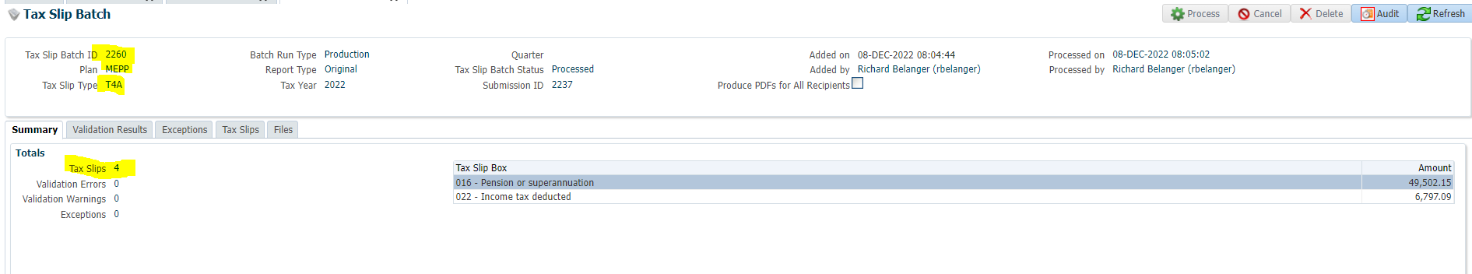

Tax Slips Tab

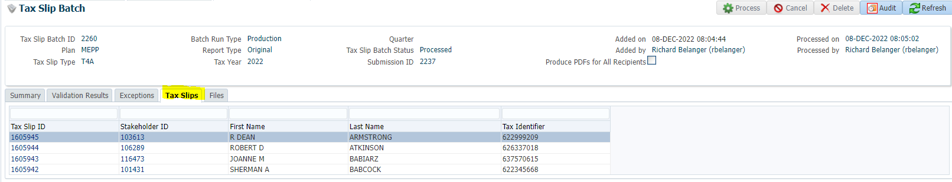

Files Tab

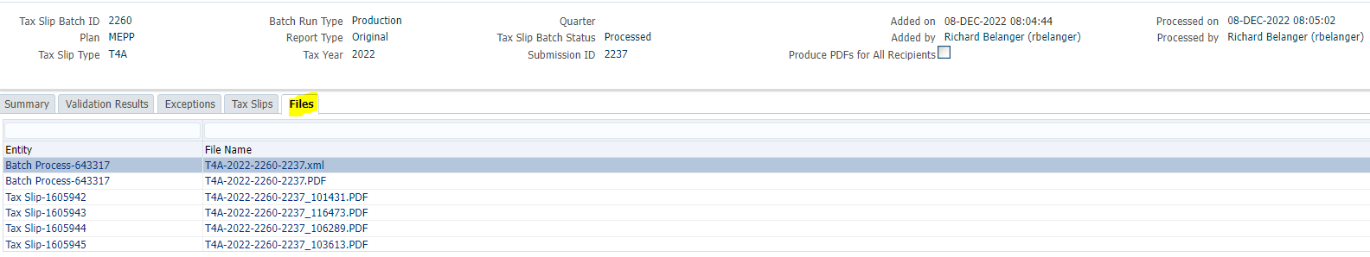

Open .XML file

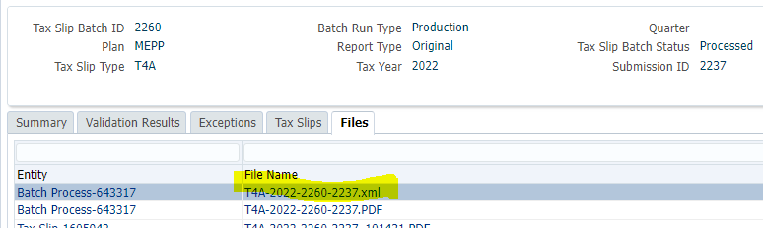

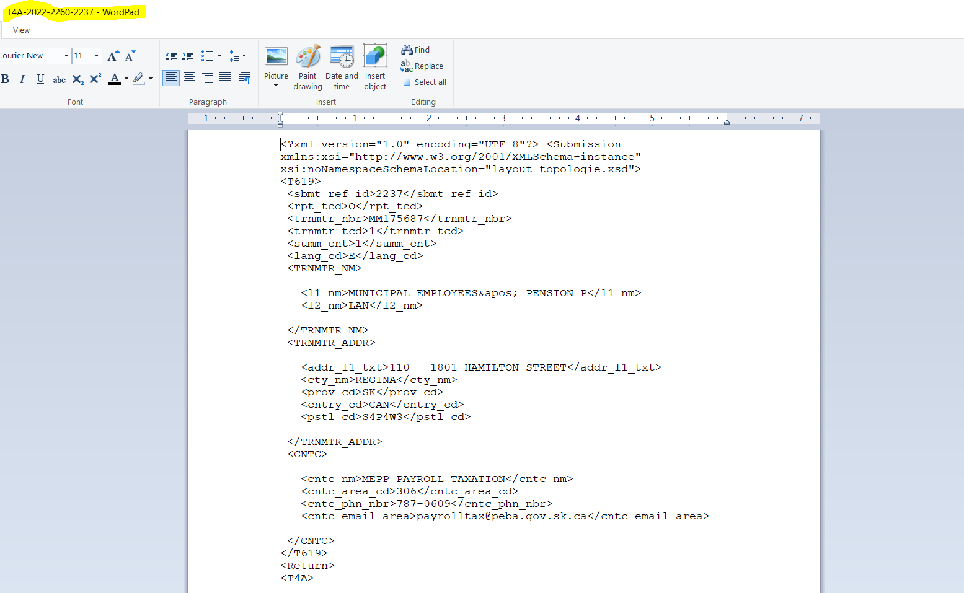

Open .PDF file

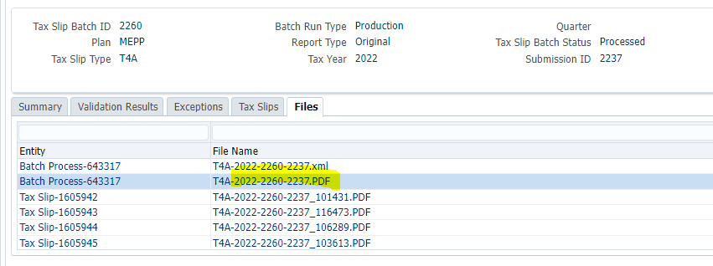

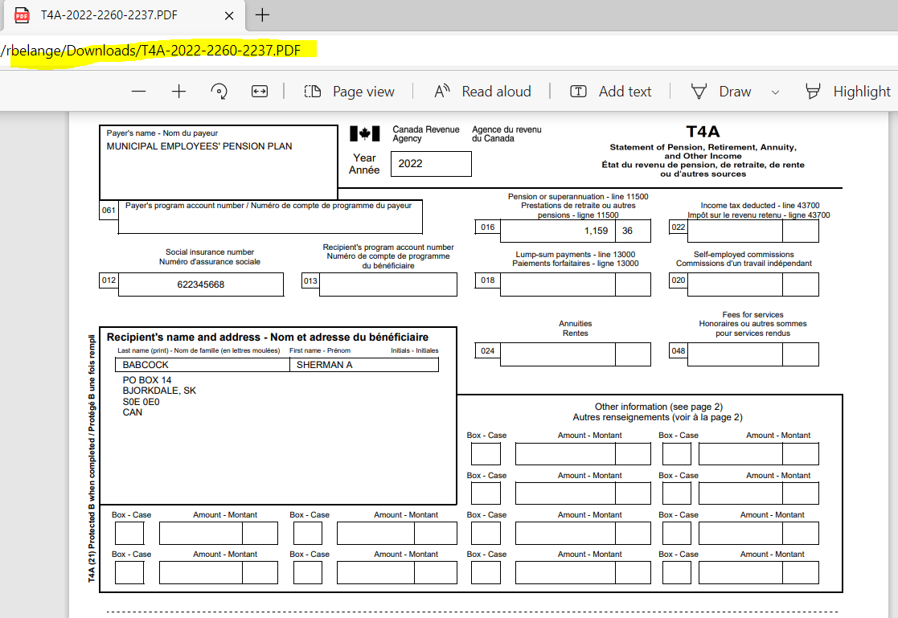

Member’s Account

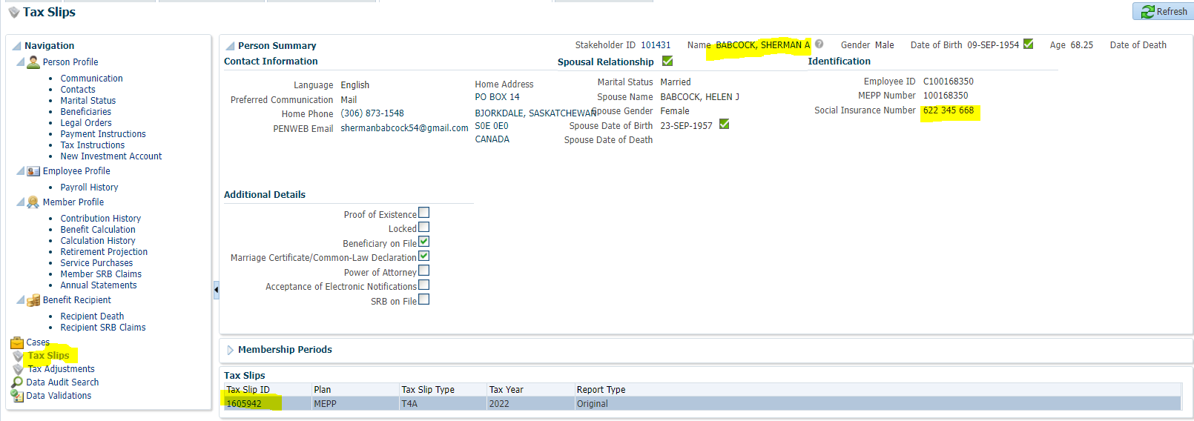

Person Profile>Communication

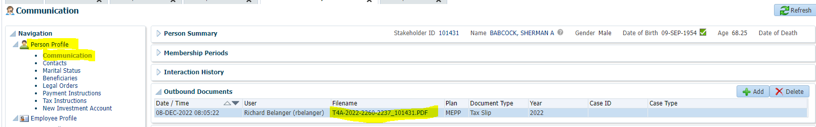

Click File name hyperlink for stored .PDF

